Lab 3
MySQL DML Commands
There will be 3 tables in this session- Employee, Department and Dependent. The scenario is about an organization where records about their employees are kept by these 3 tables. The schema diagram is as follows.

Employee
PK | SSN
 | FNAME
 | MINIT
 | LNAME
 | BDATE
 | ADDRESS
 | GENDER
 | SALARY
 | SUPERSSN
 | DNO
Department
PK | DNUMBER
 | DNAME
 | MGRSSN
 | MGRSTRATDATE

Dependent
PK | ESSN  DEPENDENT_NAME
 | GENDER
 | BDATE
 | RELATIONSHIP

In this database schema, the attributes in each table represent specific details about departments, employees, and their dependents. Here’s a breakdown of each attribute’s role:
DEPARTMENT Table
- dname: The name of the department (e.g., "RESEARCH").
- dnumber: A unique identifier (primary key) for each department. This ensures each department has a distinct number.
- mgrssn: The Social Security Number (SSN) of the manager for that department. This connects the department to the manager in the employee table.
- mgrstartdate: The date the manager started managing this department.
EMPLOYEE Table
- fname: The first name of the employee.
- minit: The middle initial of the employee.
- lname: The last name of the employee.
- ssn: The Social Security Number of the employee, serving as the primary key. It uniquely identifies each employee.
- bdate: The birthdate of the employee.
- address: The address of the employee.
- gender: The gender of the employee, represented by a single character (M for male, F for female).
- salary: The salary of the employee.
- superssn: The SSN of the employee’s supervisor. This creates a hierarchical link within the employee table.
- dno: The department number (foreign key) indicating which department the employee works in, linking to the dnumber in the department table.

DEPENDENT Table
- essn: The SSN of the employee who has the dependent. This foreign key links the dependent to the employee in the employee table.
- dependent_name: The name of the dependent, which, combined with essn, serves as part of the primary key, ensuring unique dependents per employee.
- gender: The gender of the dependent (M for male, F for female).
- bdate: The birthdate of the dependent.
- relationship: The relationship of the dependent to the employee (e.g., "SON," "DAUGHTER," "SPOUSE").

Let’s create the tables!
CREATE TABLE department (
dname VARCHAR(15),
dnumber INT NOT NULL,
mgrssn INT,
mgrstartdate DATE,
PRIMARY KEY (dnumber)
);

CREATE TABLE employee (
fname VARCHAR(15),
minit VARCHAR(2),
lname VARCHAR(15),
ssn INT(12) NOT NULL,
bdate DATE,
address VARCHAR(35),
gender VARCHAR(1),
salary INT(7) NOT NULL,
superssn INT(12),
dno INT NOT NULL,
PRIMARY KEY (ssn),
CONSTRAINT fk_dno_dnumber FOREIGN KEY (dno) REFERENCES department (dnumber)
);

CREATE TABLE dependent (
essn INT,
dependent_name VARCHAR(15),
gender VARCHAR(1),
bdate DATE,
relationship VARCHAR(12),
PRIMARY KEY (essn, dependent_name),
CONSTRAINT fk_essn_ssn FOREIGN KEY (essn) REFERENCES employee (ssn)
);
Data Insertion into a Table
Syntax:
INSERT INTO <table name> (attribute1, attribute2, ...)
VALUES (<value for attribute1>, <value for attribute2>, ...)
Example:
Insert into department (dept_name, building, budget)
values ( 'CSE', 'Main Campus', 1000000)

*** If you are adding values for all the columns of the table, you do not need to specify the column names in the SQL query. However, make sure the order of the values is in the same order as the columns in the table. Here, the INSERT INTO syntax would be as follows:
INSERT INTO table_name
VALUES (value1, value2, value3, ...);
Example:
Insert into department values ( 'CSE', 'Main Campus', 1000000)

Let’s insert some data into our tables!
-- Insert values into department table
INSERT INTO department VALUES ('RESEARCH', 5, 333445555, '1978-05-22');
INSERT INTO department VALUES ('ADMINISTRATION', 4, 987654321, '1985-01-01');
INSERT INTO department VALUES ('HEADQUARTERS', 1, 888665555, '1971-06-19');

-- Insert values into employee table
INSERT INTO employee VALUES
('JOHN','B','SMITH',123456789,'1955-01-09','731 FONDREN, HOUSTON, TX', 'M',30000,333445555,5);
INSERT INTO employee VALUES
('FRANKLIN','T','WONG',333445555,'1945-12-08','638 VOSS, HOUSTON, TX', 'M',40000,888665555,5);
INSERT INTO employee VALUES
('ALICIA','J','ZELAYA',999887777,'1958-07-19','3321 CASTLE, SPRING, TX', 'F',25000,987654321,4);
INSERT INTO employee VALUES
('JENNIFER','S','WALLACE',987654321,'1931-06-20','291 BERRY, BELLAIRE, TX', 'F',43000,888665555,4);
INSERT INTO employee VALUES
('RAMESH','K','NARAYAN',666884444,'1952-09-15','975 FIRE OAK, HUMBLE, TX', 'M',38000,333445555,5);
INSERT INTO employee VALUES
('JOYCE','A','ENGLISH',453453453,'1962-07-31','5631 RICE, HOUSTON, TX', 'F',25000,333445555,5);

INSERT INTO employee VALUES
('AHMAD','V','JABBAR',987987987,'1959-03-29','980 DALLAS, HOUSTON, TX', 'M',25000,987654321,4);
INSERT INTO employee VALUES
('JAMES','E','BORG',888665555,'1927-11-10', '450 STONE, HOUSTON, TX', 'M',55000,NULL,1);

-- Insert values into dependent table
INSERT INTO dependent VALUES (333445555,'ALICE','F','1976-04-05','DAUGHTER');
INSERT INTO dependent VALUES (333445555,'THEODORE','M','1973-10-25','SON');
INSERT INTO dependent VALUES (333445555,'JOY','F','1948-05-03','SPOUSE');
INSERT INTO dependent VALUES (123456789,'MICHAEL','M','1978-01-01','SON');
INSERT INTO dependent VALUES (123456789,'ALICE','F','1978-12-31','DAUGHTER');
INSERT INTO dependent VALUES (123456789,'ELIZABETH','F','1957-05-05','SPOUSE');
INSERT INTO dependent VALUES (987654321,'ABNER','M','1932-02-26','SPOUSE');

Now
1. Try to delete Employee table by “DROP TABLE employee;” command. What does
mySQL say? As it contains a foreign key which is the primary key of Department table,
it won’t allow you to drop Employee table.
2. Try to delete Department table as well by “DROP TABLE department;” command.
Again, it won’t allow you to delete it.
3. The only table you can delete among the 3 tables is Dependent table.
So, if you want to delete all the tables, you need to drop dependent first, then employee and then department.

Retrieving/Searching some Data/rows/records/results from database table (SQL query)
Syntax:
SELECT <column_name_needs_to_be_shown>
FROM <table_name>
WHERE <some_condition>
Example:
• Ques: Show firstName, lastName, age from the students table whose student_id is 1163172
Ans:
SELECT firstName, lastName, age
FROM students
WHERE student_id = 1163172
• Ques: Show everything (or every detail) of the employee named ‘John Doe’ from the employee table
Ans: (Hint * means everything/all the columns)
SELECT *
FROM employee
WHERE employee_name = ‘John Doe’ – (remember, if it’s a string we have to put it under single quotations)
Now, take a look at the first two tables- Department and Employee.
SELECT * FROM department;
SELECT fname, lname, dno FROM employee;
SELECT fname, lname, dno
FROM employee
WHERE dno=5;

Data Modification in a Table
Syntax:
UPDATE <table name>
SET <attribute name> = <new value>
WHERE <someCondition_on_column_values>;
Example:
Update department
set budget = 1500000
where dept_name = 'CSE';
Note: Be careful when updating records in a table! Notice the WHERE clause in the UPDATE statement. The WHERE clause specifies which record(s) that should be updated. If you omit the WHERE clause, all records in the table will be updated!
Suppose you want to update the salary of an employee with the ssn of 123456789 to a new salary of 35000:
UPDATE employee
SET salary = 35000
WHERE ssn = 123456789;

If you want to update the manager's SSN (mgrssn) in the department table for the RESEARCH department to a new manager with SSN 987987987:
UPDATE department
SET mgrssn = 987987987
WHERE dname = 'RESEARCH';

Data Deletion from a Table
Syntax:
DELETE FROM <table name>
WHERE <someCondition>;
Example:
Delete from department
Where budget<10000;
Note: Be careful when deleting records in a table! Notice the WHERE clause in the DELETE statement. The WHERE clause specifies which record(s) should be deleted. If you omit the WHERE clause, all records in the table will be deleted!
Try to execute
following statements and observe what oracle is saying.
DELETE FROM department WHERE dnumber=5;
DELETE FROM employee WHERE dno=5;
Again take a look at the last two tables- Employee and Dependent.
SELECT ssn, fname, lname FROM employee;
SELECT essn, dependent_name FROM dependent;
You can see that employee ssn 123456789 has 3 dependents from dependent table and from employee table, you can see that employee’s name is John Smith.
Now, try to execute the following statement .
DELETE FROM employee WHERE ssn= ‘123456789’;

Note: Deleting an employee may affect referential integrity if there are records in the dependent table that reference the employee's ssn. You may need to delete or update the related records in dependent before deleting the employee, or use ON DELETE CASCADE in the foreign key constraint when creating the table.
It means- if you
delete data on the master table, all the related entries in detail table will be deleted
automatically.

CREATE TABLE dependent (
essn INT(12),
dependent_name VARCHAR(15),
gender VARCHAR(1),
bdate DATE,
relationship VARCHAR(12),
PRIMARY KEY (essn, dependent_name),
FOREIGN KEY (essn) REFERENCES employee (ssn) ON DELETE CASCADE
);

With ON DELETE CASCADE, when an employee is deleted from the employee table, all dependents associated with that employee (based on essn) will automatically be deleted from the dependent table.

Conditions in SQL
• Mathematical operators such as <; >; <=; >=; =; ! =; <>;+;−; *; ~:%
• logical operators such as AND, OR, NOT
example:
• Ques: Find the productNames and their stocks from the products table those have stocks
greater than 100 units and MSRP is at least 50 units
Ans:
SELECT productNames, stocks
FROM products
WHERE stocks > 100 AND MSRP >= 50

The MySQL LIMIT Clause
The LIMIT clause is used to specify the number of records to return.
The LIMIT clause is useful on large tables with thousands of records. Returning a large number of records can impact performance.

LIMIT Syntax
SELECT column_name(s)
FROM table_name
WHERE condition
LIMIT number;

MySQL MIN() and MAX() Functions
The MIN() function returns the smallest value of the selected column.
The MAX() function returns the largest value of the selected column.

MIN() Syntax
SELECT MIN(column_name)
FROM table_name
WHERE condition;

MAX() Syntax
SELECT MAX(column_name)
FROM table_name
WHERE condition;

MySQL COUNT(), AVG() and SUM() Functions
The COUNT() function returns the number of rows that matches a specified criterion.

COUNT() Syntax
SELECT COUNT(column_name)
FROM table_name
WHERE condition;
The AVG() function returns the average value of a numeric column.

AVG() Syntax
SELECT AVG(column_name)
FROM table_name
WHERE condition;
The SUM() function returns the total sum of a numeric column.

SUM() Syntax
SELECT SUM(column_name)
FROM table_name
WHERE condition;

Patterns in SQL
The LIKE operator is a logical operator that tests whether a string contains a specified pattern or not.
MySQL provides two wildcard characters for constructing patterns: percentage % and underscore
_ .
• The percentage ( % ) wildcard matches any string of zero or more characters.
• The underscore ( _ ) wildcard matches any single character at its position

The formation of % operator:
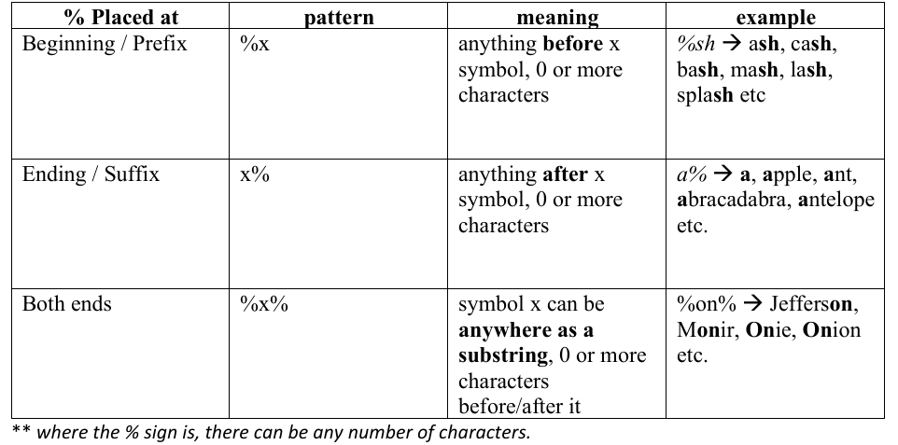

Example:
%on% -> Jefferson, Monir, Onie, Onion etc.

o Find employees’ employeeNumber, lastName, firstName whose last names end with the literal string ‘on’
SELECT employeeNumber, lastName, firstName
FROM employees
WHERE lastName LIKE '%on';

o Find all employees employeeNumber, lastName, firstName whose last names contain the substring ‘on’:
SELECT
employeeNumber,
lastName,
firstName
FROM
employees
WHERE
lastname LIKE '%on%';
The formation of _ (underscore) operator:
o Must match both position and length.
o Must be filled up by a single symbol where the underscore is (same as the fill in the gaps)

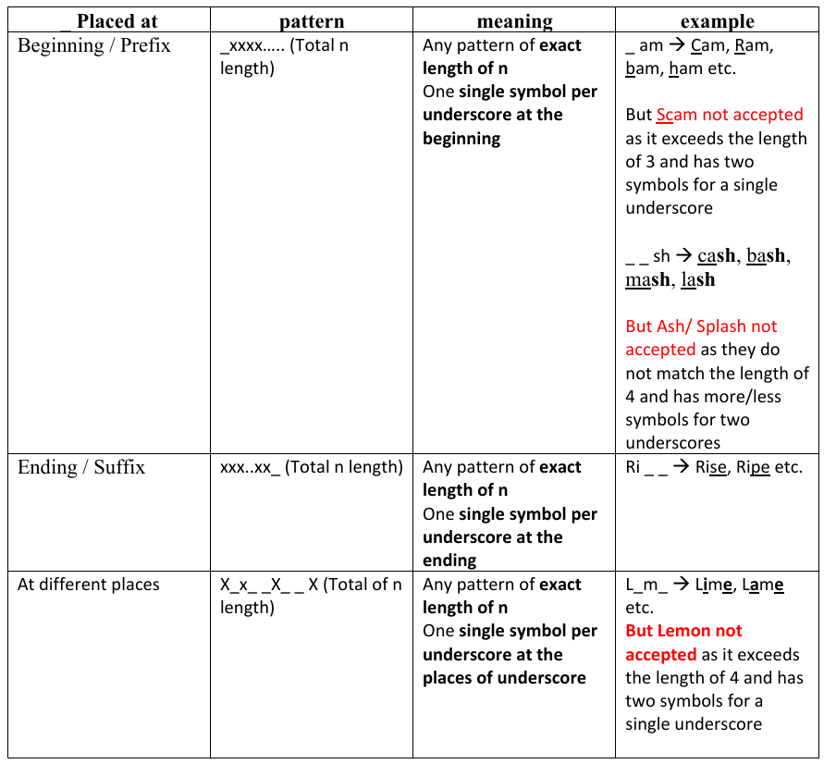

Example:
To find employees whose first names start with the letter T_m (eg. Tim. Tom etc), end with the letter m, and contain any single character between.
SELECT employeeNumber, lastName, firstName
FROM employees
WHERE firstname LIKE 'T_m';
Important note on % and _
• % -> position must match but length doesn’t matter
• _ -> position and length must match

Use of DISTINCT

DISTINCT is used to eliminate repeating elements.

- SELECT dno FROM employee;
- SELECT DISTINCT (dno) FROM employee;

Take a look at the difference between them.

Calculated Fields

You can make numerical calculations on related columns of a table also. In this case, we will divide the salary of employees who have department number 5.

- SELECT (salary/5) FROM employee WHERE dno=5;

Giving the column a different name

When you are showing data by SELECT command, you can put the column name to be shown as your wish by AS clause. Remember, this naming is just for showing. It has no impact on the actual column name of the table.

- SELECT (salary/5) AS salary_divide_by_five FROM employee;

Comparison Search Condition

- SELECT fname FROM employee;
- SELECT fname FROM employee
WHERE dno>1;
See the difference.
Compound Comparison Search Condition

- SELECT fname, lname
FROM employee
WHERE dno=1 OR dno=5;

You can use AND operator also. See the result.

Range Search Condition
Take a look at the BETWEEN clause here.

- SELECT fname, lname
FROM employee
WHERE salary BETWEEN 40000 AND 50000;
Take a look at the NOT BETWEEN clause here.
- SELECT fname, lname
FROM employee
WHERE salary NOT BETWEEN 40000 AND 50000;

Look at the range operators <= and >= here. These are more flexible than BETWEEN and NOT BETWEEN clauses.

SELECT fname, lname
FROM employee
WHERE salary>= 40000 AND salary <=50000;

Set Membership

- SELECT fname, lname
FROM employee
WHERE salary IN (30000, 40000);

This finds out the first and last name of those who has salary exactly 30000 or 40000. Similarly the following statement negates it.

- SELECT fname, lname
FROM employee
WHERE salary NOT IN (30000, 40000);

Pattern Matching

Try to execute following statements one by one.
- SELECT fname, lname, address
FROM employee;
- SELECT fname, lname, address
FROM employee
WHERE address LIKE ‘%houston%’;
- SELECT fname, lname, address
FROM employee
WHERE address LIKE ‘%HOUSTON%’;
Found any difference? The second one does not work as the table has data in all capitals. That is why the third one works.

Single Column Ordering
This time we will use ORDER BY clause. It is used to represent data in the tables in some particular (and desired) order.
- SELECT fname, lname, salary, dno
FROM employee
ORDER BY salary;
- SELECT fname, lname, salary, dno
FROM employee
ORDER BY salary desc;
Which one is by default- ascending or descending?
Multiple Columns Ordering

When you are using multiple columns in ORDER BY clause, please be careful. Because, sometimes it is difficult to see the difference in actual results.
- SELECT fname, lname, salary, dno
FROM employee
ORDER BY salary, dno;
In this case, the result will be-
FNAME LNAME SALARY DNO
ALICIA ZELAYA 25000 4
AHMAD JABBAR 25000 4
JOYCE ENGLISH 25000 5
JOHN SMITH 30000 5
RAMESH NARAYAN 38000 5
FRANKLIN WONG 40000 5
JENNIFER WALLACE 43000 4
JAMES BORG 55000 1
- SELECT fname, lname, salary, dno
FROM employee
ORDER BY salary, dno desc;
In this case the result will be-
FNAME LNAME SALARY DNO
JOYCE ENGLISH 25000 5
ALICIA ZELAYA 25000 4
AHMAD JABBAR 25000 4
JOHN SMITH 30000 5
RAMESH NARAYAN 38000 5
FRANKLIN WONG 40000 5
JENNIFER WALLACE 43000 4
JAMES BORG 55000 1

You can find out the difference in the first 3 rows where salary is all 25000. take a look at the change in ordering regarding to the department number.

